Project Design Phase
Solution Architecture
Date | 15 February 2026
Team ID | SWTID-2026-1597
Project Name | AI Fit Track API – Personalized Fitness Tracking with AI-Powered Insights
Maximum Marks | 4 Marks

Solution Architecture:
AI Fit Track API follows the MVC pattern to separate business logic from data management. Requests from a client pass through the Express routing layer, authentication and sanitisation middleware, and then to the controllers. Controllers use the service layer for statistics aggregation and Gemini AI calls, and the Mongoose model layer for persistence in MongoDB. A centralised error handler returns consistent JSON errors.
- Routing layer (View) – maps /api/auth, /api/workouts, /api/stats, /api/insights and /api/admin to controllers.
- Middleware – JWT verification with a role matrix, request sanitisation and central error handling.
- Controllers – Auth, Workout, Stats, AI Insight and Admin.
- Service layer – stats aggregation service and Gemini AI integration service with a fallback text generator.
- Model layer – Mongoose schemas for User and WorkoutLog (one-to-many) stored in MongoDB.
Solution Architecture Diagram:
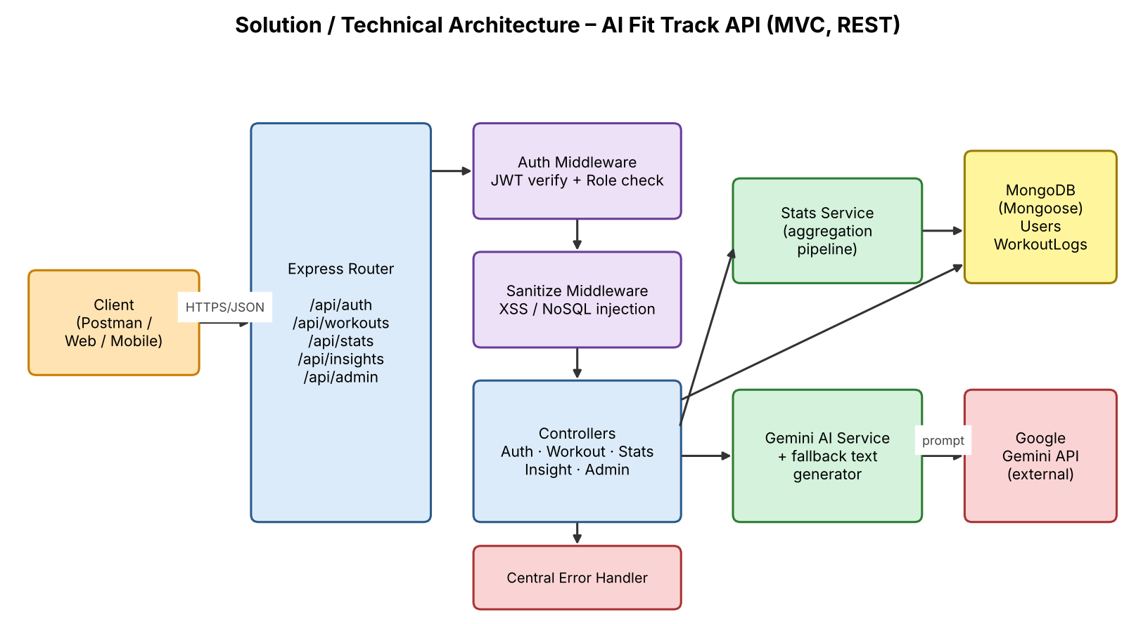
Figure 1: Architecture and data flow of AI Fit Track API
Request flow:
- The user registers or logs in and receives a JWT.
- The user logs workouts and goals, which are stored in MongoDB.
- The Stats API aggregates recent activity into weekly and monthly summaries.
- The Insight API sends the user's recent data to Gemini AI and returns a summary and recommendations, or a fallback response if the AI is unavailable.

